RESOLUTION NO.__________

RE: CERTIFICATE OF APPROPRIATENESS UNDER THE
PROVISIONS OF THE ACT OF THE PENNSYLVANIA
LEGISLATURE 1961, JUNE 13, P.L. 282 (53
SECTION 8004) AND BETHLEHEM ORDINANCE NO.
3952 AS AMENDED.

WHEREAS, it is proposed to replace windows and construct an enclosed porch at the rear of the house at 234 E. Market St.

NOW, THEREFORE, BE IT RESOLVED by the Council of the City of Bethlehem that a Certificate of Appropriateness is hereby granted for the proposal.

Sponsored by: (s)

(s)

ADOPTED BY COUNCIL THIS DAY OF

(s)
President of Council

ATTEST:

(s)
City Clerk

HISTORICAL & ARCHITECTURAL REVIEW BOARD

The applicant proposes to replace windows and construct an enclosed porch at the rear of the house at 234 E. Market St.
APPLICATION #1:

Frank & Beth Boyer
234 E. Market St.
Bethlehem, PA 18018

OWNER:

__________________________________________________________________

The Board upon motion by Phil Roeder and seconded by Marsha Fritz adopted the proposal that City Council issue a Certificate of Appropriateness for the following:

- Replace all but three windows, excluding basement windows. Windows to match existing windows in size, muntin size and configuration.

2. Windows to be Marvin wood units with simulated divided lights painted to match
existing.

3. Porch to be served by a new brick stairway matching the existing house. Porch
roof to be GAF Slateline in Antique Slate Grey color.

4. All work to be in accordance with the Secretary of Interior Standards.

5. The motion was unanimously approved.

__________________________________________________________________________

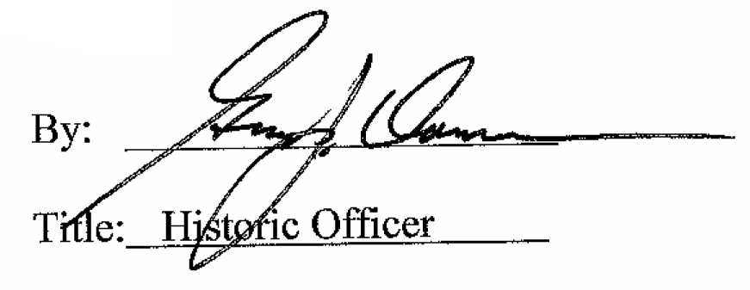

Date of Meeting: March 2, 2016

